**“*National Instruments LabVIEW Install Quick Reference Guide*”**

# **TABLE OF CONTENTS**

**TABLE OF CONTENTS** 2

**REVISION LOG** 3

**PROCEDURE STATUS** 3

**REFERENCES** 3

**PURPOSE** 3

**SCOPE** 3

**PERSONNEL TRAINING AND QUALIFICATION** 3

**APPARATUS AND EQUIPMENT** 3

**PREREQUISITE** 5

A. “Y” Drive Setup 5

**PROCEDURE** 6

**A.** **NI Developer Suite 2015 DS2 Install** 6

**B.** **Software Activation** 37

**C.** **Software Activation** 43

# **REVISION LOG**

|  |  |  |  |  |
| --- | --- | --- | --- | --- |
| **Revision: 1.0** | | **Effective Date:** | | |
| **Section** | **Justification** | | | **Changes** |
|  |  | | |  |
| **Impact of above change(s) on other documents:** | | |  | |

# **PROCEDURE STATUS**

The status of this procedure is: **DRAFT.**

# **REFERENCES**

1. <https://www.ni.com/en.html>
2. [https://www.ni.com/en/support/downloads/software-products/download.labview.html#521715](https://www.ni.com/en/support/downloads/software-products/download.labview.html%23521715 )
3. \\c1315mv65\groups\Private\TestSupport\JADEC Commissioning\Software\National Instruments
4. <https://www.ni.com/pdf/manuals/374715c.html>

# **PURPOSE**

This quick start guide provides instructions on how to install National Instruments LabVIEW in preparation for working with JCI Software Projects.

# **SCOPE**

This procedure applies to all personnel who will be using National Instruments Software Products at JCI.

# **PERSONNEL TRAINING AND QUALIFICATION**

1. System Users need to have proficiency with:
   1. Microsoft Windows
   2. National Instruments Software
2. Access to “Y” Drive

# **APPARATUS AND EQUIPMENT**

Minimum System Requirements for National Instruments LabVIEW.

|  |  |  |
| --- | --- | --- |
| **Windows** | **Run-Time Engine** | **Development Environment** |
| Processor | Pentium III/Celeron 866 MHz (or equivalent) or later (32-bit) Pentium 4 G1 (or equivalent) or later (64-bit) | Pentium 4M (or equivalent) or later (32-bit) Pentium 4 G1 (or equivalent) or later (64-bit) |
| RAM | 256 MB | 1 GB |
| Screen Resolution | 1024 x 768 pixels | 1024 x 768 pixels |
| Operating System | Windows 8.1/8/7/Vista (32-bit and 64-bit) Windows XP SP3 (32-bit) Windows Server 2012 R2 (64-bit) Windows Server 2008 R2 (64-bit) Windows Server 2003 R2 (32-bit) | Windows 8.1/8/7/Vista (32-bit and 64-bit) Windows XP SP3 (32-bit) Windows Server 2012 R2 (64-bit) Windows Server 2008 R2 (64-bit) Windows Server 2003 R2 (32-bit) |
| Disk Space | 620 MB | 5 GB (includes default drivers from the NI Device Drivers media) |
| Color Palette | N/A | LabVIEW and the *LabVIEW Help* contain 16-bit color graphics. LabVIEW requires a minimum color palette setting of 16-bit color. |
| Temporary Files Directory | N/A | LabVIEW uses a directory for storing temporary files. National Instruments recommends that you have several megabytes of disk space available for this temporary directory. |
| Adobe Reader | N/A | You must have Adobe Reader installed to search PDF versions of all LabVIEW manuals. |

# **PREREQUISITE**

## **“Y” Drive Setup**

* 1. Navigate to “This PC”



* 1. A screenshot of a computer

     Description automatically generatedSelect “Map network drive” form the Ribbon
  2. A “Map Network Drive” Window will open prompting some information.

* + 1. Use the drop down and select “Y” for the “Drive”.
    2. Enter \\c1823m003.go.johnsoncontrols.com\yorkdata\esg\Dept1892 into “Folder”
    3. Verify “Reconnect at Sign-in” is selected.
    4. Verify “Connect using different credentials” is not selected.
    5. Press “Finish”
  1. This will now close the “Map Network Drive” Window and open an additional Windows Explorer Window with the “Y” Drive contents.

# **PROCEDURE**

## **NI Developer Suite 2015 DS2 Install**

1. From the mapped “Y” Drive, navigate to Groups\Private\TestSupport\JADEC Commissioning\Software\National Instruments
2. Open the Folder “LabVIEW 2015”
3. Open the Folder " 501400AP-01M_2015DS2DVD1_ENG”
4. A screenshot of a computer

   Description automatically generatedRun Setup.exe (Application) by right clicking and selecting
5. A screenshot of a software suite

   Description automatically generated A “NI Developer Suite 2015 DS2” Window will open. This window will direct the user thru the installation process. Press “Next” to proceed.
6. A screenshot of a computer

   Description automatically generatedThe next setup screen will display. This screen prompts the user to “Select Installation Option”. That option is whether to use a serial number or to just evaluate the product.
7. Verify that “I have serial numbers for one or more products in this installer.” Is selected.
8. Verify “Select and activate products based on my serial numbers.” is selected.
9. Press “Next” to proceed.
10. The next Screen will prompt the user to enter serial number(s).
    1. A screenshot of a computer

       Description automatically generatedFor each serial number:
       1. Enter the serial number in the provided text box.
       2. Press “Add Serial Number”
       3. A screenshot of a computer

          Description automatically generatedAnother “NI Developer Suite 2015 DS2” Window will display to validate the serial number.
       4. A serial number for “LabVIEW Professional” and “LabVIEW Real-Time Module” will be entered.
       5. A screenshot of a computer suite

          Description automatically generatedWhen both serial numbers are validated. Press “Next” to proceed.
11. The next screen will prompt the user to select the “Product(s)” from the “Licensed Product List”
    1. A screenshot of a software suite

       Description automatically generatedClick the drop down on “VI Package Manager” and select the option Install.
    2. A screenshot of a software suite

       Description automatically generatedClick the drop down on “NI General Security Patch Q2 2013” and select the option Install.
    3. A screenshot of a computer program

       Description automatically generated Click the drop down on “NI Device Drivers – August ” and select the option Install.
    4. A screenshot of a software suite

       Description automatically generatedPress “Next” to proceed.
12. A screenshot of a computer

    Description automatically generatedThe next screen is prompting the user to determine if they want to check for important updates to the products they are choosing to install. Please verify that the box is checked and press “Next” to proceed.
13. A screenshot of a computer

    Description automatically generatedThe next screen will proceed to check for any important updates to the selected products. When it is done, it will go away and proceed to the next screen.
14. A screenshot of a computer

    Description automatically generatedThe next screen will go over any important updates for the selected products. There should be no updates.

Press “Next” to proceed.

1. A screenshot of a computer

   Description automatically generatedThe next screen will provide a list of directories for install files. Press “Next” to proceed.
2. A screenshot of a software license agreement

   Description automatically generatedThe next screen will ask the user to accept the license agreements. Please select “I accept the above x License Agreement(s).” and press “Next” to proceed.
3. A screenshot of a computer screen

   Description automatically generatedThe next screen is more license agreement acceptance. Please select “I accept the above x License Agreement(s).” Press “Next” to proceed.
4. 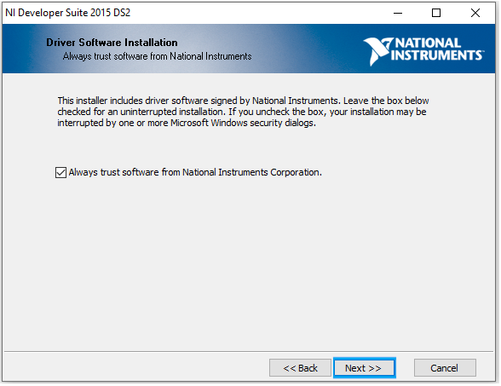The next screen is prompting the user to always trust software from National Instruments Corporation. Verify “Always trust software from National Instruments Corporation.” is selected. Press “Next” to proceed.
5. A screenshot of a computer error

   Description automatically generatedThe next screen will try to active the products. It may show a “Page Error” or need to be refreshed. This is due to the software being older and web pages changing. Press “Next” to proceed.
6. A screenshot of a software application

   Description automatically generatedThe next screen will prompt for user information. Please fill in “First Name”, “Last Name”, “Organization”, and “Email”. Press “Next” to proceed.
7. A screenshot of a software update

   Description automatically generatedThe next step will verify the products to be installed and once “Next” is pressed, installation will begin. Press “Next” to proceed.
8. Screens screenshot of a computer

   Description automatically generatedInstallation will now begin. Please wait for it to finish before proceeding. The screen may flash and/or command prompts may appear. This is normal.
9. During Installation, the user will be prompt to enter the location for Disc 2, Disc 3, and Instrument Drivers. There can be found on the “Y” Drive at:
   1. A screenshot of a computer error message

      Description automatically generated Disc 2 – “Groups\Private\TestSupport\JADEC Commissioning\Software\National Instruments\LabVIEW 2015\501400AP-02M_2015DS2DVD2”
   2. A screenshot of a computer error message

      Description automatically generatedA screenshot of a computer error message

      Description automatically generatedDisc 3 – “Groups\Private\TestSupport\JADEC Commissioning\Software\National Instruments\LabVIEW 2015\ 501400AP-03M_2015DS2DVD3”
   3. A screenshot of a computer error message

      Description automatically generatedInstrument Drivers – “Groups\Private\TestSupport\JADEC Commissioning\Software\National Instruments\NI Device Drivers\Aug15\DCD-Aug15-1”
10. A screenshot of a computer screen

    Description automatically generatedFor the Instrument Drivers, the user is prompted to accept x License Agreements. At this screen, please select “I accept the above x License Agreement(s).” Press “Next” to proceed.
11. Screens screenshot of a computer

    Description automatically generatedInstallation will continue.
12. A screenshot of a computer

    Description automatically generatedOnce installation is complete, a “Product Information” screen will display. This screen displays information about the products that were installed. Press “Next” to proceed.
13. A screenshot of a computer program

    Description automatically generatedThe next screen is the “Installation Summary”. This screen shows all of the products that were installed. Press “Next” to proceed.
14. A screenshot of a message

    Description automatically generatedAfter the previous screen is advanced, a “NI Update Service” window displays. Select “Yes” to prompt the software to check for updates.
15. A screenshot of a computer

    Description automatically generatedAnother prompt will now appear, alerting the user that the installer will now connect to a website to install “Windows Software Development Kit”. Press “Yes” to proceed.
16. A screenshot of a software development kit

    Description automatically generatedA “Windows Software Development Kit for Windows 8.1” window will now display. Keep all settings default and press “Next” to proceed.
17. A screenshot of a computer program

    Description automatically generatedThe next screen will ask the user to “Join the Customer Experience”. Verify “No” is Selected and then press “Next” to proceed.
18. A screenshot of a computer software application

    Description automatically generatedThe next screen is a “License Agreement” screen. Press “Accept” to proceed.
19. A screenshot of a software update

    Description automatically generatedThe next screen will prompt the user to “Select the features you want to install”. Verify “Windows Software Development Kit” is selected and press “Install” to start installing.
20. A screenshot of a computer program

    Description automatically generatedThe software will begin to install. Please, wait for the installation to complete.
21. 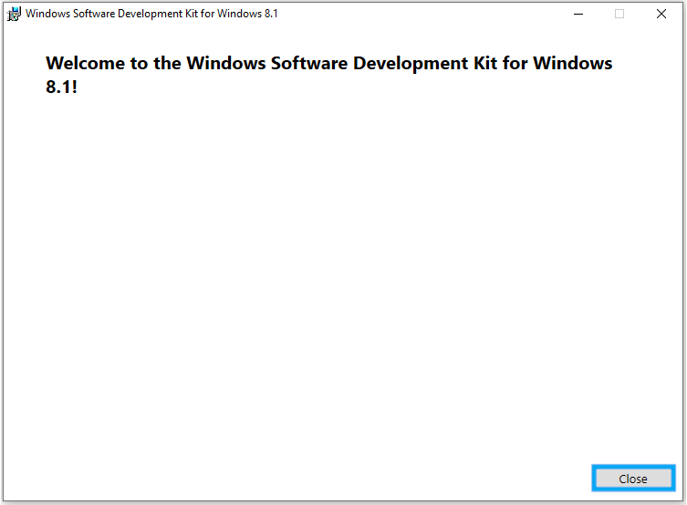After installation if complete, a “Welcome” screen will appear. Press “Close” to close the window.
22. A computer error message

    Description automatically generatedAn “NI Developer Suite 2015 DS2” window will appear. This prompt will ask the user to restart the PC to complete installation. Press “Yes” to proceed.
23. The PC will now restart.
24. A screenshot of a computer security alert

    Description automatically generatedAfter Windows reboots, there will e a “Windows Firewall” Prompt. Press “Allow Access” to proceed.
25. A screenshot of a software update

    Description automatically generatedA “NI Update Service” Window will come up after this. Press “Remind Me Later”

## **Software Activation 2015 Developer Suite**

1. A screenshot of a computer

   Description automatically generatedFrom the start menu search, type “NI License Manager”. Then select "NI License Manager”.
2. A screenshot of a computer

   Description automatically generatedNI License Manager will then open.
3. A screenshot of a computer

   Description automatically generatedExpand “LabVIEW 2015”. Right click on “Professional Development System” and select “Activate”.
4. A screenshot of a computer

   Description automatically generatedFollow instructions, entering the serial number, when prompted, until successful activation of “Professional Development System”.
5. A screenshot of a computer

   Description automatically generated\Expand “Modules” and then expand “Real-Time Module”. Right click on “Real Time Development” and select “Activate”.
6. A screenshot of a computer

   Description automatically generatedFollow instructions, entering the serial number, when prompted, until successful activation of “Real-Time Module”.
7. Close “Ni License Manage”.

## **LabVIEW 2015 SP1**

1. From the mapped “Y” Drive, navigate to Groups\Private\TestSupport\JADEC Commissioning\Software\National Instruments
2. Open the Folder “2015sp1LV-WinEng”
3. A screenshot of a computer

   Description automatically generatedRight click on “Setup” and select “Run JCI Elevated”
4. A screenshot of a computer

   Description automatically generatedA screen will display to start the Installation. Press “Next” to proceed.
5. A screenshot of a computer

   Description automatically generatedThis screen will display the user information. It should be populated. If it is not, populate it as shown. Press “Next” to proceed.
6. A screenshot of a computer

   Description automatically generatedEnter at last the serial number for “LabVIEW 2015 SP1”. Press “Next” to continue.
7. A screenshot of a computer

   Description automatically generatedThis screen will ask for the destination directory. Leave them default. Press “Next” to proceed.
8. A screenshot of a computer program

   Description automatically generatedThis screen will ask the user to confirm the features to be installed. Leave all default. Press “Next” to proceed.
9. A screenshot of a computer

   Description automatically generatedThis screen will prompt the user about “Product Notifications”. Verify that “Search for important updates” is checked and press “Next” to proceed.
10. A screenshot of a computer

    Description automatically generatedThe next screen will search for important product updates. There should not be any but, if there are, install them. Press “Next” to proceed.
11. A screenshot of a computer screen

    Description automatically generatedThe next screen will prompt the user to accept x “License Agreements”. Select “I accept the License Agreement” and press “Next” to proceed.
12. A screenshot of a computer

    Description automatically generatedThis next screen will confirm what is being installed and by clicking “Next”, installation will begin. Press “Next” to proceed.
13. A screenshot of a computer

    Description automatically generatedInstallation will begin. The next screen will go thru progress and install the software. Please, wait for it to complete.
14. A screenshot of a computer error message

    Description automatically generatedAn Option for installing support will come up towards the end of installation. Press “Decline Support” to proceed.
15. A screenshot of a computer

    Description automatically generatedWhen installation is complete, the next screen will display, notifying that installation is complete. Press “Next” to continue.

## **Software Activation 2015 SP1**

1. A screenshot of a computer software

   Description automatically generated After LabVIEW 2015 SP1 Installation, a prompt to activate the software will come up. Verify “Automatically activate though a secure Internet connection” is selected and press “Next” to proceed.
2. A screenshot of a computer

   Description automatically generatedThe next screen will prompt the user for their serial number for activation. Verify or enter the correct serial number and press “Next” to proceed.
3. A screenshot of a computer

   Description automatically generatedThe next screen will try to active the products. It may show a “Page Error” or need to be refreshed. This is due to the software being older and web pages changing. Press “Next” to proceed.
4. A screenshot of a software system

   Description automatically generatedThe next screen will prompt for the user information. Verify or enter the information displayed and press “Next” to proceed.
5. A screenshot of a computer

   Description automatically generatedThe application will then activate the product(s). Upon completion, a multiple “Products Successfully Activated!” screens will display. Press “Finish” to proceed with each one.
6. A screenshot of a computer error

   Description automatically generatedA final screen will display asking the user to “restart the computer to complete this operation”. Press “Restart” to proceed.

## **NI Update Service**

1. A screenshot of a computer

   Description automatically generatedOn Windows Start Search type “NI Update Service” and select “NI Update Service”.
2. A screenshot of a computer

   Description automatically generatedThe window will then search NI.com for Updates.
3. A screenshot of a computer

   Description automatically generatedSelect “LabVIEW 2015 SP1 (32-bit) f10 Patch”
4. A screenshot of a computer

   Description automatically generatedSelect “R Series Multifunction RIO Q1 2016 Patch for LabVIEW 2015”, LabVIEW Run-Time Engine 2014 SP1 (32-bit) f11 Patch”, LabVIEW Run-Time Engine 2014 SP1 (64-bit) f11 Patch”, and “LabVIEW Run-Time Engine 2015 SP1 (64-bit) f2 Patch LabVIEW Run-Time Engine 2015 SP1 (32-bit) f10 Patch”
5. A screenshot of a computer

   Description automatically generatedExpand “Upgrades and Service Packs (2)” The window will now check NI.com.

1. A screenshot of a computer

   Description automatically generatedSelect “LabVIEW 2015 SP1 Real-Time Module – English”. Press “Install” to start installing updates.
2. A screenshot of a computer

   Description automatically generated“NI Update Services” will then download and install the selected updates. Please wait for it to finish.